- Appointment Survey
Northdown Surgery – 2016 November – Appointment Survey
Number of Responses: 232

Q1. How did you arrange your most recent appointment
Online 9%
By telephone 63%
In person 25%
No response 3%
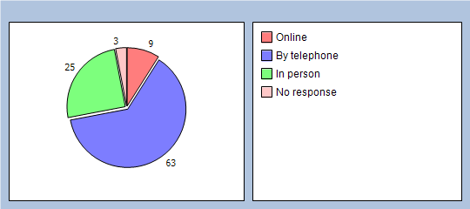

Q2. How satisfied with the appointment booking process were you
Satisfied 73%
Unsatisfied 23%
No response 4%
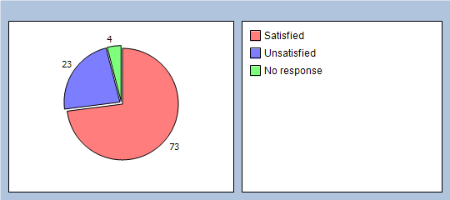

Q3. How long did you have to wait before you could get your appointment
Same day appointment 44%
3 days 15%
1 week 18%
2 weeks 10%
Unable to get appointment to suit me 5%
No response 8%
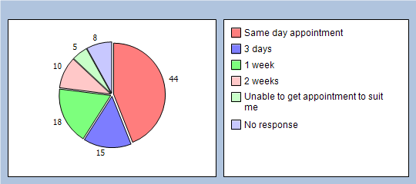

Q4. Who did you see at the surgery
GP 56%
Advanced Nurse Practitioner 13%
Paramedic Practitioner 3%
Nurse 20%
Health Care Assistant 1%
Physiotherapist 1%
Counsellor 0%
No response 6%
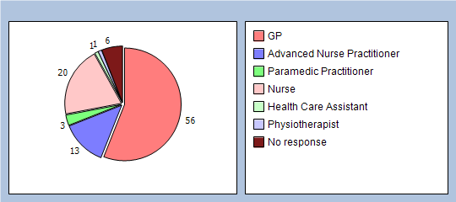

Q5. How satisfied were you with your consultation
Satisfied 91%
Not satisfied 6%
No response 3%
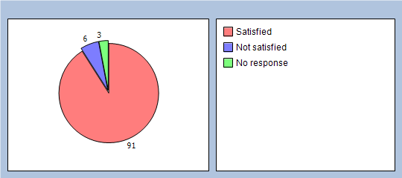
Thank you for taking part in our survey, your participation is important to the surgery. There is a suggestion box within the Reception waiting area for your suggestions, however if you wish to leave any other comments, please do so here.

Patient Comments
- >> 15 minutes late <<
- >> 42 calls over 20 minute period <<
- >> After being discharged from hospital, I was instructed that I needed a follow up review with a GP one week later. I had expected to have to do battle with reception to try to persuade them to book an appointment some days ahead, but to my surprise there was one online appointment slot available with Dr Braga 8 days after my hospital discharge so I took that one. Not being able to book an appointment via reception for some days or weeks ahead is still a big bug-bear, is unrealistic and needs to be addressed with urgency. <<
- >> Always exceptionally difficult to get through on the phone and never able to get a same day and have to keep calling back daily. <<
- >> appointment was made for me 1 month ago <<
- >> As usual had to call a number of times before I could get through (144 times) but I appreciate at opening there is a high call volume - shame there's not a call queuing system. <<
- >> blood test was booked 2 weeks n advance <<
- >> Fantastic Nurses! Really helped when my son got upset. Fantastic team! <<
- >> had to wait 2 weeks to be able to see a nurse <<
- >> had to wait 5 weeks for appointment <<
- >> I have ongoing weekly appointments arranged at previous appointment. <<
- >> I have used the online service, which is good in as fare as I didn't need an emergency or immediate appointment. Phoneing to get an appointment is extremely frustrating so I now queue up and phone whilst in the queue <<
- >> I phoned two mornings from 8 to 8.25 a.m. in order to obtain an appt. with a GP, but in the end had to accept a telephone apt. two days later. Accepted the telephone apt. with a Dr.(Dr, Ryder) who I knew & who had read my discharge note from QMQE Hosp. so he was able to advise us. We had explored all other channels ie Dietitian, the Ward I was on & Gastroentrologist who was on leave that week and, any case, discharge note said contact your GP. I do feel It was better in the old days not having an apt. system whereby you turned up at the surgery and waited sometimes one or two hours, but at least you were seen?? Mrs June Hornblower <<
- >> I spent 4 weeks trying to get a medical letter for my benefits, then after 4 weeks waiting I was then asked to make an appointment, then another 2 weeks, just to be asked questions which I could have answered via email or on the phone or simply forwarded the letter I sent to DWP. As a result of all this my claim has probably been cancelled. <<
- >> like that the doors open at 8.25am and phone lines at 0800 <<
- >> next day <<
- >> not my usual doctor though <<
- >> On-line appointments do seem few and far between with GPs and for ongoing or chronic health problems where one doesn't need an urgent appointment it seems the obvious way to me. I also think there should be some sort of tag on records for attendance. I've never, ever missed an appointment and if at anytime have had none that I no longer need I call. However, for a recent appointment I got two text alerts and a letter - overkill and a waste of someone's time. Surely its ok to put the simple fact of a 'missed appointment without notice' on a record so you know who does need reminding. <<
- >> Q3 used three phones at once to make phone calls to surgery Q4this time saw GP but usually only nurse then have to make another appointment which is impossible <<
- >> Suggestion i would try and keep the doctors and other staff you have because i have done some research and seen that 3 of your staff went to westgate surgery. would of thought you would of done all you could to keep the staff northdown is going down hill fast. <<
- >> The 8am scramble (via phone/in person) for same day only appointments is ridiculous. Best practice for appointments, i.e. booked in advance (days/weeks in advance) done in most customer service providers is the accepted norm. This GP practice is not an A&E where only urgent - same day cases are seen. <<
- >> the nurse arranged my appointment <<
- >> The nurses didn't have all the equipment to finish me - I had to come again <<
- >> These questions are not a true statement as they are only asking right or wrong with no in-between <<
- >> This time phoning is not an option <<
- >> Usually very difficult to get an appointment to see a GP <<
- >> very satisfied <<
- >> why does it take so long on the phone to get through and make an appointment. <<
- >> why should we explain our personal illness to the receptionist to get an appointment which is undignified. <<

